**1) Scale riddle. With 8 balls ☺ EXAM [1,1,1,1,2,1,1,1]. One of the items will be change to two. Indexes are t be chosen at random. Use compressions only two times.**

2) * Create a solution that will tell us what poker set we have. The solution is to deal us 5 cards from the standard 52 card deck. After that the solution is to tell us what is the best poker set. **EXAM**

3) (EXAM) Solve sudoku

Start

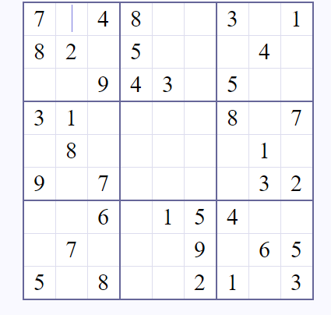

Solution

